**Assisted Practice: 3.4 Create an EBS Volume**

This section will guide you to:

* Change the volume size of an instance

This lab has six subsections, namely:

3.4.1 Selecting the **volume** tab in the EC2 dashboard

3.4.2 Creating a new volume by clicking on **Create**

3.4.3 Selecting the volume type according to the project requirement

3.4.4 Creating a new volume by specifying the size and defining the zone

3.4.5 Verifying the new volume created on the volume console and its availability

3.4.6 Pushing the code to GitHub repositories

**Step 3.4.1:** Selecting the **volume** tab in the EC2 dashboard

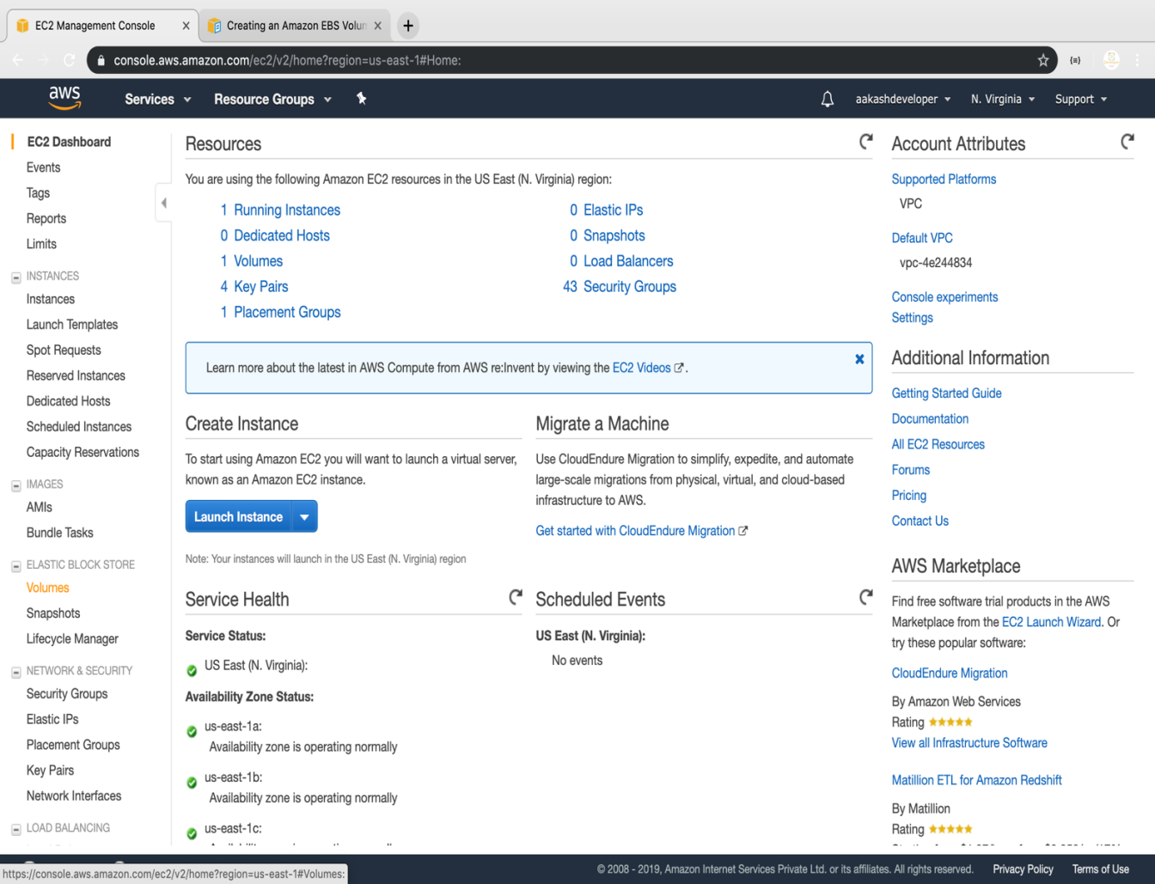

**Step 3.4.2:** Creating a new volume by clicking on **Create**

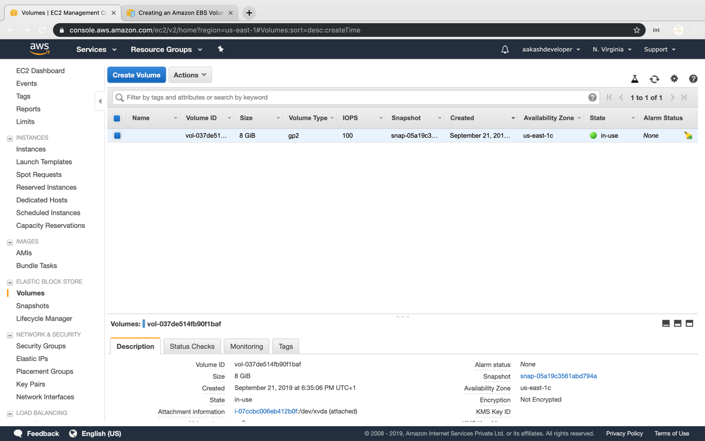

**Step 3.4.3:** Selecting the volume type according to the project requirement

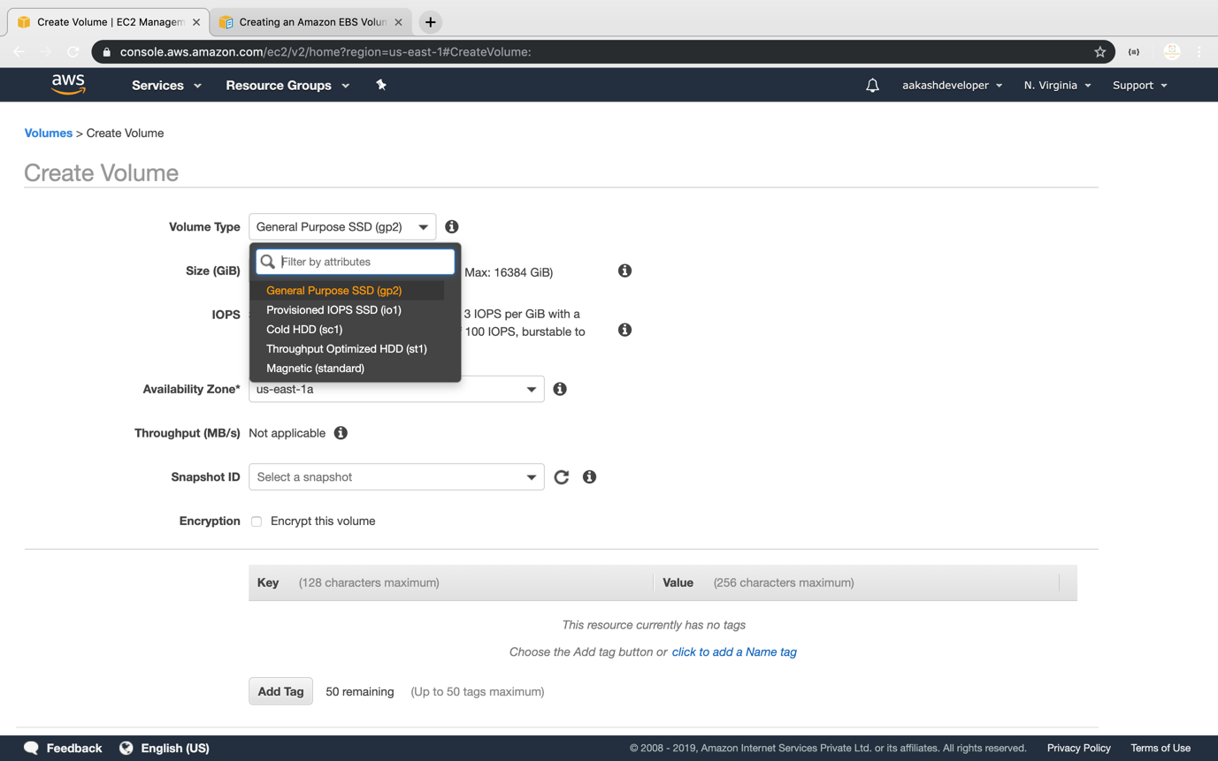

**Step 3.4.4:** Creating a new volume by specifying the size and defining the zone

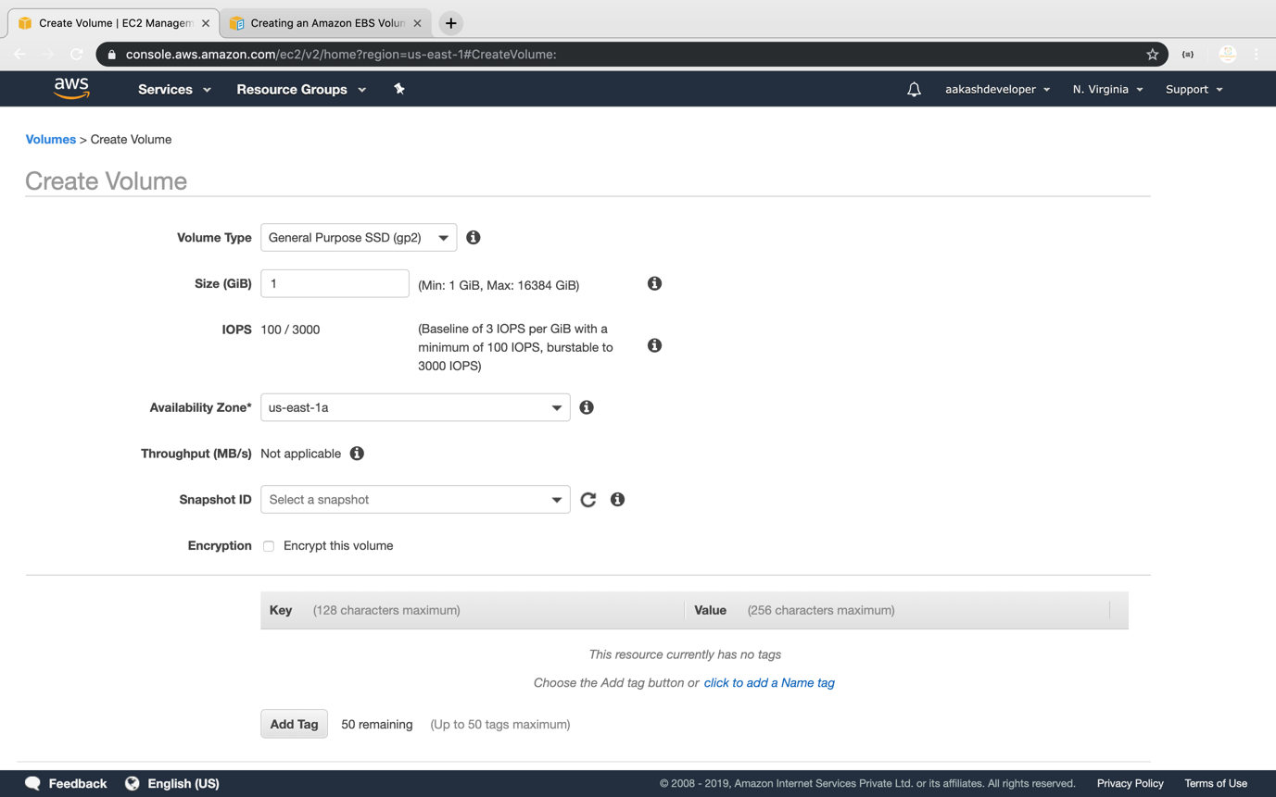

**Step 3.4.5:** Verifying the new volume created on the volume console and its availability

